



# MATTU UNIVERSITY

# COLLEGE OF ENGINEERING AND TECHNOLOGY DEPARTMENT OF CIVIL ENGINEERING

## FINAL INTERNSHIP REPORT FOR FOURTH YEAR CIVIL ENGINEERING

 **Duration of Internship**: Three Months, April -9/2023 to July –9/2023 G.C 



 **HOSTING COMPANY:** BURAYU SUB CITY CONSTRUCTION OFFICE. 

 **Name of Student ID.NO. **

 1 Tolera Negasa……………………………………………RU/4346/13

2 Milkiyas Getachew …………………………………….RU/0383/13

3 Ermias Gamada …………………………………………RU/2816/13

4 Bona Tariku …………………………………………….RU/4134/13





#### Advisor’s Name: Mr Regasa Yadeta. (MSc)

Submission Date: 06/10/2023

 September-2023 

#### Mattu, Oromia, Ethiopia.



# DECLARATION

This document is prepared by Tolera negasa,Milkiyas Getachew,Ermias Gamada, Bona Tariku as a final internship report after four months training in the Company of BURAYU SUB CITY CONSTRUCTION OFFICE on the projects of Residential house that is found in Burayu town. This internship report is approved by guidance of our mentor **Mr Regasa Yadeta** and the company site supervisor engineer **Alamayo Daksisa.**

we assure that the report contains actual events and facts that was observed and performed during the internship practice program. The contents of the report are based on the internship report outline which was given by our department. our academic advisor certifies this document**.**

**Approval of Advisor:** Mr Regasa Yadeta. **Signature Date** _

**Student’s Name: Tolera Negasa Signature Date**

**Milkiyas Getachew**

**Ermias Gamada**

**Bona Tariku**

# ACKNOWLEDGMENT

First of all we would like to praise the **almighty GOD** for all his supporting in any direction during our internship activites.

Next, we have extend supreme gratitude to MaU, College of Engineering and Technology for providing such kind of good opportunity for students to broaden their perception on how the real world in the field of Civil Engineering looks like as well as organizing the whole internship that program and its effort to make sure.

Thirdly, we would like to express also very thankful to BURAYU SUB CITY CONSTRUCTION OFFICE. for providing this us opportunity to learn and gain this priceless experience from their working area.

Fourthly, we would like to convey our heartiest thanks to our advisor **Mr.Regasa Yadeta.** and our mentor Eng **Alamayo Daksisa.** for his endless support at site and by consulting us how to do things in the site and how to write this report in outstanding manner, as well as all teachers of Civil Engineering who brought us to our present performance and shape we like this during the last three successive years.

Finally,before we finish we would like to give our deepest thanks to all the Company stakeholders like project manager(**Mr.Bira**),contractor,client, foreman, and the consultant side starting from beginning to the last our activities.

# EXECUTIVE SUMMERY

These four months of practice made us confidential with our knowledge and skills that the student has gotten from Mattu University. That means, we have gained great knowledge and skills about site and office works within four months in BURAYU SUB CITY CONSTRUCTION OFFICE during our internship period.

The objectives of internship is To improve practical skill and team playing skill, To develop the knowledge on reading structural and architectural drawing, To improve interpersonal communication skill and To understand about work ethics related issue.

This internship report contains four chapters in which we try to explain our four month experience in our hosting company. The content of all chapters is broadly explained and it is constructed from the practical basis of the site work ended all months. In the **first chapter** give details to the company background including its mission, vision, the project those runs through the company works. In this chapter we put all record or history and futurity of our hosting company with its official address. So, it is give details of the company in terms of reader can easily know and access the company. The **second chapter** is the main chapter which explains our overall internship familiarity in the last successive months. we record on it the overall work we have been executing. It gives a high light what we have been doing and main works of the construction industry. After all those chapters explained above we goes to the **third chapter** and explains the main benefits of the internship class in terms of different aspects and areas. It is obvious that the internship has a plus in terms of improving skills and different abilities as a whole. The advantages and gains of the internship putted in short and prices way to grasp the attention of readers and evaluators.The final and **fourth chapter** explains about the winding up and suggestion on the project that our company runs. Inside the site we get many things which are appropriate and inappropriate for work in building construction, thus we comment and give my recommendation in some conditions and workings.

|  |  |
| --- | --- |
|  | **ACRONYMS** |
| Auto CAD | Automatical Computer Aided Design |
| ETABS | Extended three dimensional analysis of building |
| HCB | Hallow concrete block |
| MaU | Mattu University |
| PLC | Private limited company |
| PPC | Pozolona Portland cement |
| SAP | Sampling and analysis plan |
| UIL | University Industrial Linkage |

#### TABLE OF CONTENTS

DECLARATION I

ACKNOWLEDGMENT II

EXECUTIVE SUMMERY III

LIST OF FIGURE IV

CHAPTER ONE 1

INTRODUCTION 1

* 1. Back Ground of Hosting Company 1
  2. The Vision of the Company 2
  3. The Mission of the Company 2
  4. Objective of the Company 2
  5. Main Product and Service 3
  6. Main customers or end users of product 3
     1. Ongoing Projects 3
     2. Completed Projects 4
  7. Overall Organization Structure, Management And Work Flow 4
  8. Information of project where I have been working on it 5
  9. Construction Equipment‟s 6

CHAPTER TWO 7

OVER ALL EXPERIENCE OF INTERNSHIP 7

* 1. How I Get the Company 7
  2. The Section In Which I Have Been Working 7
  3. The Work Flow In The Section 8
  4. The Work Tasks I Have Been Executing 10
     1. Office Work 10

1. Bar Schedule Preparing 11
2. Bill of quantity (BOQ form) 11
3. Reading Construction Drawing 11
   * 1. Site work 12

A. Earth Work and Excavation 12

* + 1. Form Work 20
    2. Concrete work 21
    3. Types of concrete 25

1. Reinforced Concrete 25
2. Lean Concrete. 27
   * 1. Spacer 27
     2. Vibrator 28
     3. Stripping time 28
   1. The Procedures I have Been Using While Performing My Work Tasks 29
   2. How Good I have Been in Performing My Work Task 30
   3. Challenge I have Been Facing While I Perform My Work Task 31
   4. Measure to Overcome Challenges 31

CHAPTER THREE 32

OVERALL BENEFITS OF INTERNSHIP 32

* 1. In Terms of Practical Skill 32
  2. In Terms of Upgrading Theoretical Knowledge 33
  3. In Terms of Improving Interpersonal Communication Skills 33
  4. In Terms of Improving Team Playing Skill 33
  5. In Terms of Improving Leadership Skill 34
  6. In Terms of Understanding Work Ethics 34
  7. In terms of updated software 35

CHAPTER FOUR 36

RECOMMENDATION AND CONCLUSION 36

* 1. Conclusion 36
  2. Recommendation 38
     1. Recommendation for the company 38
     2. Recommendation for the University 38

REFERENCE 39

APPENDIX 40

**LIST OF TABLE**

Table 2-1 Format of takeoff sheet for concrete and formwork 10

Table 2-2 Bar schedule format 11

Table 2-3 Specification worksheet BOQ form 11

Table 2-4 Mix proportion 25

Table 2-5 Spacer size 28

Table 2-6 Stripping time of formwork 28

## LIST OF FIGURE

Figure 1-1 Company Organization Flow Chart 5

Figure 1-2 Concrete mixer track 6

Figure 1-3 Vibrator 6

Figure 1-4 Mixer 6

Figure 1-5 panel 6

Figure 2-1 Work flow in section at site 8

Figure 2-2 Site clear. 13

Figure 2-3 Bulk excavation 13

Figure 2-4 Offseted line from profile board. 13

Figure 2-5 Back fill 13

Figure 2-6 Isolated footing 15

Figure 2-7 Combined footing 15

Figure 2-8 Hardcore 16

Figure 2-9 Ground slab 17

Figure 2-10 Massonary work 18

Figure 2-11 Casted elevation column 19

Figure 2-12 Plywood 21

Figure 2-13 Panel… 21

Figure 2-14 Aggregate 23

Figure 2-15 Sand… 23

Figure 2-16 Water tank. 23

Figure 2-17 Cement… 23

Figure 2-18 Batching material 23

Figure 2-19 Concrete mixing 24

Figure 2-20 Fresh concrete. 24

Figure 2-21 Reinforcement concrete 27

Figure 2-22 Reinforcement bar… 27

Figure 2-23 Spacer for footing 28

Figure 2-24 Stripping top tie beam. 28

Figure 2-25 Vibration process 29

Figure 2-26 Current figure of building 29

**CHAPTER ONE** **INTRODUCTION**

The theoretical education should be supported by practice. This four months of practice made us confidential with our knowledge that the students has gotten from Mattu University. That means, we have gained great knowledge and skills about site and office works within four months in BURAYU SUB CITY CONSTRUCTION OFFICE during our internship period. The report was written on time stay for four months where different activities were done on the site and by asking some information from professional persons. This report has concerned with describing what we have been working in our internship period. The overall views of a report written were to discuss ideas and skills what we gained in practical period; how to read design drawing and knowing materials and equipment used at the construction site.

#### Back Ground of Hosting Company

BURAYU SUB CITY CONSTRUCTION OFFICE was established in year 2010 G.C in the objective of creating reliable and visionary construction firm that will expand on continental level on long term basis. since conception, the company has moderately contributed to the economic development to the country. So that why we got a chance to meet with the company which it is constructing building in Burayu town. because of our institute MaU lead us to have a practical experience. This company are experienced in providing quality services, products and helps client‟s designs, build and logistics through a network of facilities covering most areas of Ethiopia. BURAYU SUB CITY CONSTRUCTION OFFICE is a unique competitive value is their commitment to deliver their services through team work spirit with other stakeholders and their objective of handling a project with a few to none contractual claim matters that may bring disputes and a consequent failure to the project.

#### Quality Policy

The company has permanent employees of professionals and is structured to project-specific recruitment plan for the required level of expertise as per the scope of the contracts. Likewise, if the Equipment and machineries owned by the company are found to be insufficient, an alternate lease-scheme shall be made applicable to ensure no delay is exhibited in carrying out of the works. All performances and contractual undertaking shall involve professionals who are experienced specific to the assigned project and can take full responsibility to manage the works as per the agreed task schedule and time frame.

Annually assessed by their managers to determine adequacy of their existing training / qualification, and to propose what additional training they require. ***“Quality, not Quantity is company Policy*.**

#### The Vision of the Company

SIMLESS CONSTRUCTION PLC Create a company with robust managerial technical and financial capacity as a strategic objective of being competitive on continental level.SIMLESS has set of vision to become a premier solution provider company providing world leadership in complete engineering and technical solution for the construction and engineering society. SIMLESS are trying to be the leader in client satisfaction, innovation, professionalism and superior quality solution. They are the architect of responsive, fast, cost effective and creative solution to clients benefit, compensation and their critical needs.

#### The Mission of the Company

Deliver quality services to its customers, strictly comply and aware the company‟s HSQ policy , deliver its social responsibility which is one of its focus area and core value under the umbrella of the company‟s growth plan part from profitability

To form long-term relationships of value with clients and partners, using quality construction and engineering solution and employing the best resource and latest techniques. And the entire office members are working to have the following strategic goals.

* Professionalism
* Honesty
* Efficiency and standard quality
* Respect for clients

#### Objective of the Company

The important specific objectives of the Company are listed as follow:

* To provide the highest possible standard of quality and service in the construction industry
* Maintain maximum level of customer satisfaction
* Ensure the financial endurance of the company
* Ensure the professional development of its staff
* Contribute to the development of the construction industry by providing safe constructions
* The company can offer the best resources and latest technology

#### Main Product and Service

SIMLESS CONSTRUCTION PLC is actively involved Road Construction, building Construction, water work, and Machinery rental projects all over the country.

* **Road Construction** is all about creating an unbroken passage of appropriate materials that don‟t have any geographic obstacles for effective vehicle or foot travel.
* **Steel structure works**:-We construct warehouses for industrial facilities starting from foundation works. We have professional who are experienced in the cost-effective design ensuring serviceability.
* **Building Construction** is one of our company works with high quality that fit the space, time, and cost of the project
* **Water Works** is done by our company starting from the founding of the company with precision on water tight material
* **Fuel stations**:-We construct fuel stations which involve hot mix asphalt Forecourt. Fuel tank installations, washing ramp and, Forecourt concrete pavement works, canopy installation and other related works

#### Main customers or end users of product

* + - Governmental body
    - Private person
    - Community
* **The government body**: all companies of the project so many relations with the government starting from tax payment up to taking contracts from the government in order to construct different building for different purposes.
* **Private person*:*** in the private sector the main customers are investors. In the private sector most of the buildings are mixed-use buildings, Hotels and main offices.

#### Ongoing Projects

The company is currently executing a number of projects among which are:-

* + Mojo town:- Store building
  + Bishoftu town:- appartama building
  + Addis Ababa Building project

#### Completed Projects

* + Bishoftu town:- Office Building project and Lounge Building project
  + Mojo town :- big store
  + Addis Ababa:- Institution maintance project

#### Overall Organization Structure, Management And Work Flow

In every organization, the most important asset is the people that play essential role in the performance of the company„s functions and responsibilities. Thus, SIMLESS CONSTRUCTION PLC is fortunate to have highly qualified and experienced personnel. Reciprocally, SIMLESS CONSTRUCTION PLC has aimed to provide its employees all the basic necessities while performing their assigned tasks and at the same time equip them through training and seminars to enhance their capabilities. The company as organization and the employees, because of the mutual benefits that simultaneously being enjoyed by, has grown tremendously and has blazed a track record of fulfilling its obligation and commitment both the customers and the community. They would like to be on the level where they should be .Having confidence in the organization, they aim high. The teamwork that has been developed through the years of hard work has reaped a harvest of opportunities and wealth. They will continue to improve and develop new concepts both in management and technology.

SIMLESS CONSTRUCTION PLC carried out any project by forming a dedicated project team. Each team is headed by a senior design engineer and draftsmen enough to complete the project in schedule. Design teams are dynamically managed to accommodate necessary and fluctuating workload and tights schedules. Flexible teaming capability enables SIMLESS CONSTRUCTION to undertake large and small project with the lowest overhead coasts thus providing the best value to the client.

The organization of the company fulfils class one contractor rules. According to its organization, it enjoys a remarkable reputation in the construction industry. Having started with regular staff members, it has now been able to create job opportunity for many permanent skilled personals and daily labourer‟s.

The general manager has chief power among different employment. He controls all activities in the company and makes decision in consultant with management and technical advisor



GENERAL MANAGER



ARCHITECTURE

BUILDING

INTERIOR

URBAN



CONTRUCT ADMIN

& SUPERVISION

FINANCE & ADMIN

SITE

COORD.

FINANCE

ADMINISTRATION

QUAN.

SERV.

LIASON

OFFICER

SITE

SUPERVISION

OFFICE.

ASSISTANCE

**Figure 1-1** Company Organization Flow Chart

#### Information of project where I have been working on it



ENGINEERING

STRUCTURAL

ELECTRICAL

MECHANICAL

SANITARY

* Project: Abissinia Group of Industry(AGI)
* Location: Bishoftu town
* Client: AGI(Abissiniya Group of Industry)
* Consultant : Metaferia Consulting Engineers and Architects
* Contractor :SIMLESS CONSTRUCTION PLC

## Company address

* Main office: Addis Ababa, gherji
* Phone no: +251913065221
* E-mail: [Seamless.fz@gmail.com](mailto:Seamless.fz@gmail.com)

#### Construction Equipment’s

* Excavator
* Damp track
* Water pump
* Mixer
* Vibrator

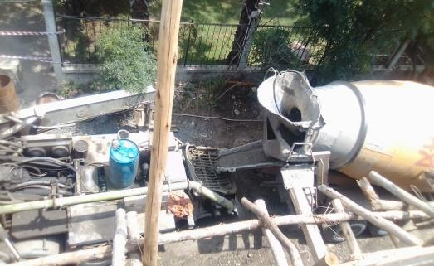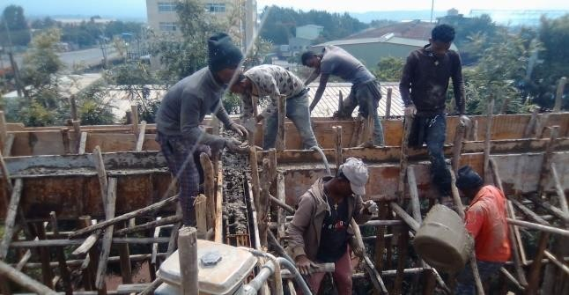

**Figure 1-2** Concrete mixer track and concrete filler track **Figure 1-3** Vibrator

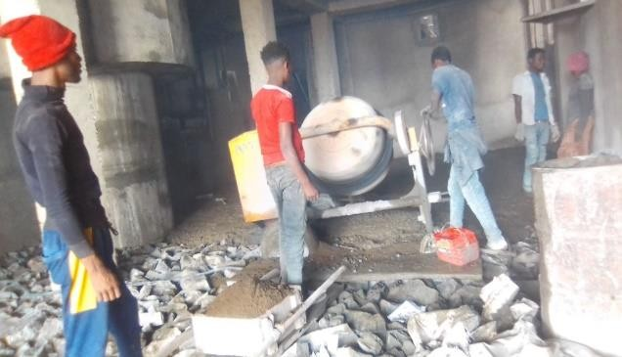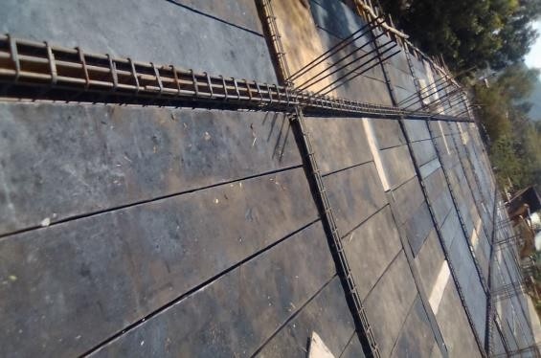

**Figure 1-4** Mixer **Figure 1-5** Panel

## CHAPTER TWO

**OVER ALL EXPERIENCE OF INTERNSHIP**

#### How I Get the Company

Construction is the mobilization and utilization of capital and specialized personal, material and equipment to assemble materials and equipment on specific site in accordance with drawings, specifications and contract documents prepared to serve the purposes of a client. I have visited a number of construction companies before setting down with this company just to make sure I completely realize what I am trying to get myself into. In addition to this, I was looking for a place where I would be able to contribute considerable inputs that would be taken seriously.

After realize all the above factors, I decided to take practice in SIMLESS CONSTRUCTION PLC, because I wanted to see the construction work starting from excavation and the construction has G+2 that‟s for apartment, which helps me to grasp a great deal of theoretical and practical knowledge at different aspects. I get in to the company by giving a letter, which was given to us from Mattu UIL offices that request describe about our internship program. After few days I submitting this letter to SIMLESS CONSTRUCTION. soon the Project Manager positively accepted my request to work as an intern student in the company.

#### The Section In Which I Have Been Working

In construction mainly there is three section involved in the construction system. These sections are client, Consultant and contractors. All these three sections have their own tasks and activity that are expected from them to perform.

1. **The Client:** is the initiator and owner of the project.
2. **The Consultant:** transfers the wish of the owner into realizable form and makes the study, design and possibly the supervision.
3. **The Contractor**: is the one who performs the work.

In fact, I have been working with contractors. As we know contractors are performing construction activity, and the supervisors will check everything that going to be checked up. In my case I am on the side of contractor, I am able to control different tasks. These tasks are mainly reinforcement check-up, the concrete quality, dimensions of different structure, form works and alignment of the structures, quantity determining, columns and beams. The concrete quality should be made in a good manner by controlling the mixing ratio of the concrete. The site engineer also helps me to gain the experience. The site engineer

is responsible for the day to day oversight of the construction site and management. The contractors are also responsible for providing, labor, equipment for construction.

#### The Work Flow In The Section

For every construction process well organized work flow is necessary for successful compilation of the project whether it is large or small. smooth work flow depends on factors like the time required to-finish the project, the number of employees involved, the scale of project, the type of the project, the location of the project site.my working site at Bishoftu town project the work flow was look like the chart below. As shown in the chart everything was excuted based on this flow. The work flow is put as figure of chart below:



**Project finance Head**

**Finance office**



**General Manager**



**store **

**Guar**

**Drive**

**Project Administration**



**Office engineer**

**General Forman**

**Site engineer**

**Project manager**

**Figure 2-1** Work flow in section at site



**Skilled and non-skilled person**

#### General Manager

General Manager is preparing meetings, with different section heads for reviewing schedules, evaluate performances, better understanding of problems and solutions, and recollection of resources, removal of doubts, acceleration plans etc.

#### Project Administration

The responsibilities of project administration:

* Prepare format for workers of the company.
* Prepare ID for the workers.
* Solve interpersonal problems between workers.
* Write experience letters to workers.

1. **Store -** Control the amount and type of material of the construction entering and leaving from the store by preparing some forms.
2. **Drivers:-**Includes all from small to large truck drivers. Transports the materials purchased and also machines in and out of the site.
3. **Guard-**responsibilities of security guard in construction site:-
   * Observes windows, doors, gates, equipment and machinery to ensure they are properly secured.
   * Issues passes and directs visitors to appropriate area.

#### Project Manager

The project manager has so many responsibilities at the site and in our site these positions is accountable for the for the contractor or the owner and are appointed by the owner of the construction company. The main duty of manager is manages the whole site work execution, Makes payment to sub contract workers, Approves material request, Analyses the work processes, Executes sub-contracting agreements, Review and checks the reports made by the office engineer.

1. **Office Engineer-** The main responsibility of office Engineers are;
   * Prepare material lists for the project.
   * Prepare payment for sub-contractors.
   * Keep contract document and detail drawing of the site.
   * Approve the work of quantity.
2. **Site Engineer**- Site engineer in construction has a responsibility to make sure that the work is implemented based on the design and based on specifications used by the company.
   * prepares daily laborer‟s output report
   * Schedules weekly or monthly work implementation
   * checks and reviews any sub contract payments
   * Quantifies any materials on request
   * Manages and supervises all activities at site
3. **General Forman-** The Forman in construction controls the distribution of Masons, Carpenter, bar bender and daily labors. He also gives guidance on how the work is to be done and gives correction if there is any mistake done.

**Skilled And Non-Skilled Persons -** This group includes masons, carpenter, bar benders (ferrayo) and the daily laborers. In our country workers of such group are appointed only by experience these have its own advantage on the construction. They work everything as they ordered by with the Forman or the site engineer.

#### Finance Office

Is responsible for acquiring funds for the firm, managing funds within the organization and planning for the expenditure of funds on various assets. The role in this company is to be charge of accurately tracking

income and expenses, monitoring budgets, reporting on the financial status of both projects and the company, and managing cash flow.

#### The Work Tasks I Have Been Executing

In my internship time I have been working in **office** and **Site Works**.

#### Office Work

This is all activities done within office, in order to implement construction process. In the office work I have been work in different unit rate analysis **such as:**

1. Bar schedule preparing
2. BOQ analysis (bill of quantity)
3. Reading construction drawing

#### Quantity Work

**Preparation of take-off sheet**

Take off sheet is a tabular standard format in which dimensions of items from the drawing are transferred to further calculations or take off sheet is a paper which measurements and quantities of materials is being recorded from the detail construction drawing.

#### While preparing takeoff sheet

* + Must use clear English with less technical words.
  + Repeated words must be avoided,
  + Non popular abbreviations must be avoided

#### Purposes of takeoff sheet preparation are:

* + To know amount of money required
  + To know the quantity of materials, equipment & tools
  + To know different workers to be employed
  + To draw up construction schedule and program

**Table 2-1** Format of takeoff sheet for concrete and formwork

|  |  |  |  |
| --- | --- | --- | --- |
| **Project:** Bishoftu town  **Client:** Abissiniya Group of Industry  **Consultant:** Metaferia Consulting Engineers and Architects  **Contractor:** SIMLESS CONSTRUCTION PLC | | | |
| Timesing(T) | Dimension(D) | Squaring(S) | Description(D) |
|  |  |  |  |
|  |  |  |  |

* + Timesing (T) -number of repetition of the same dimension
  + Dimension (D) -all necessary dimensions
  + Squaring (S) -the multiplication of dimension
  + Description (D)- work item is briefly stated.

#### Bar Schedule Preparing

**Preparation of takeoff sheet for reinforcement bars**

It is clear that the reinforcement bar is one of the essential units of a certain structural element. To prepare the take-off sheet for the reinforcement bars there is formats in use for these reason it is important to determine the type and amount of reinforcement bars required for a certain project, To know the number of 12m re-bar (berga) and manage wastage easily and the mass of a particular type (i.e. in terms of bar diameter) of bar in kilograms.

**Table 2-2** Bar schedule format

|  |  |  |  |  |  |  |  |  |  |  |  |  |  |  |
| --- | --- | --- | --- | --- | --- | --- | --- | --- | --- | --- | --- | --- | --- | --- |
| **Descrip**  **tion** | **Shape** | **Diameter** | **Length**  **(m)** | **No of**  **Bar** | **No of**  **mem** | **Total No of**  **bar** | **Type and Total of Length of Bar/s** | | | | | | | |
| 8 | 10 | 12 | 14 | 16 | 18 | 20 | 24 |
|  |  |  |  |  |  |  |  |  |  |  |  |  |  |  |
| **Total length(M) Weight per (kg) Total weight (kg)** | | | | | | |  |  |  |  |  |  |  |  |
|  |  |  |  |  |  |  |  |
|  | | | | | | | |

**Note:** In order to find the Total weight of the bars in Kg we can use the formula Bar in Kg=0.222*D2*L/36 **where:** - D is the diameter of bars in mm

* L is total length of bar in m
* 0.222 where Conversion factor

#### Bill of quantity (BOQ form)

It is the format which is used in a bill of quantity to list (include) a short description of the specification along with its measuring unit, quantity and unit prices to determine the total cost for each trade of item.

**Table 2-3** Specification worksheet BOQ form

|  |  |  |  |  |  |
| --- | --- | --- | --- | --- | --- |
| Item | Description | Unit | Quantity | Unit price | Total price |
|  |  |  |  |  |  |
|  |  |  |  |  |  |

#### Reading Construction Drawing

* **Architectural Drawing: -**shows the design of a building, open areas, and even whole communities, often with an eye to the aesthetics of the end result. Architectural drawing are consists floor plan, site plan, section, elevation, construction detail plan.
* **Structural Drawing: -** explains the design of the building. Mainly it shows details of reinforcement

for different RC members of the building. Structural drawing are consists foundation layout details, columns details, beams details, floor slabs details, staircase details and other structural parts details.

#### Site work

In section of my report, I will try to describe activities and practices that were done in my hosting company during my internship time. I was able to see the practical works starting from excavation to some super structure work. I used observation method as well as participate in activities that have done in the site to achieve our task and to find out the practical knowledge.

The following are major tasks which I have seen in the site work:

* + 1. Sub structure working and
    2. Super structure working

#### Sub Structure Working

On the construction works which are performed below normal ground level classified as substructure works. From substructure I have seen the following activities:-

1. Earth work and excavation (site clearance, bulk, pit excavation, backfill, cart away and trench excavation)
2. Concrete works (foundation, grade beam, ground slab and column)
3. Masonry work (retaing wall and masonary)

#### Earth Work and Excavation

The important activities that take place in the Earth works and excavations are:

1. **Site Clearance:-** it is the first earth work in any construction site and it is removing of topsoil and unwanted material like trees, bush. With 20 cm depth from normal ground level by considering 1m working area in all direction.
2. **Bulk Excavation: -**the removal of large amounts of soil or other material from a site that is typically required when providing large spaces below the ground level for a project.
3. **Pit Excavation:-**removal of soil from the construction site to specified depth to provide space for the intended work. In our site we observe pit excavation for footing.

#### The procedure to excavate pit

* 1. Get center of column from profile board
  2. Offset the point from center of column to the edge of excavation point and assume working space each side
  3. Get excavation point from rope by using plumb bow
  4. The depth width and length of pit excavation based on survey given data or specification

1. **Back Fill:-** is to mean replacing excavated soil or selected material.
2. **Cart Away**:- is refers to the removal of material such as soil that need to be taken away from the site.
3. 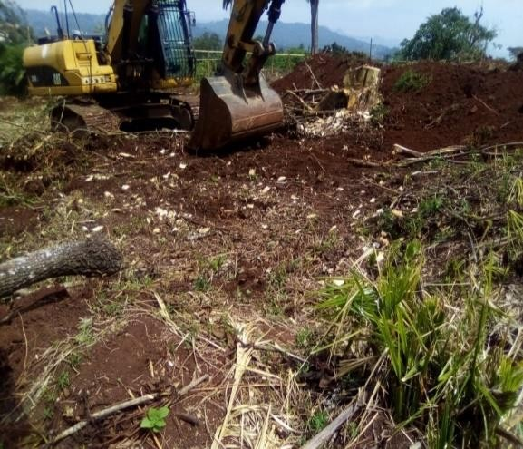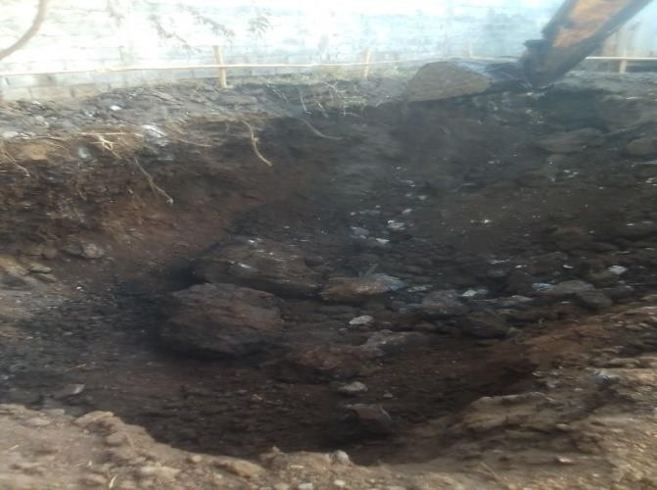**Trench Excavation:-** any excavation works for the purpose of constriction of masonry work.

**Figure 2-2** Site clear **Figure 2-3** Bulk excavation

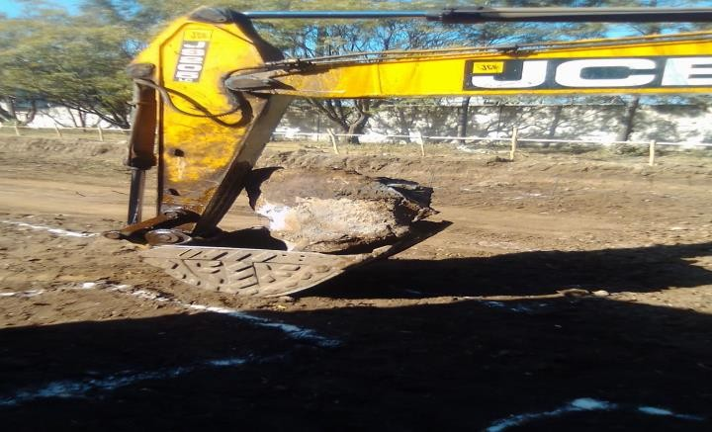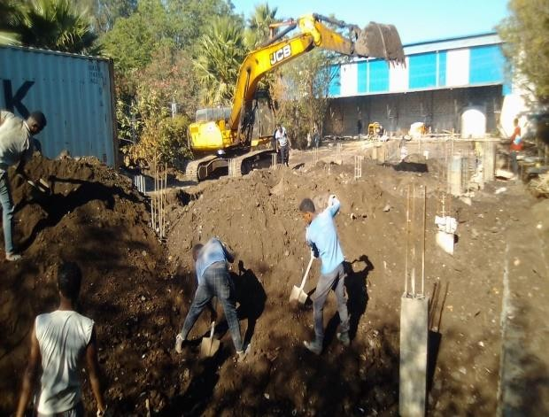

**Figure 2-4** Offset line from profile board **Figure 2-5** Back fill

* 1. **Foundation**

It is a part of a building which is in direct contact with the ground to support the weight of the building and other loads and transmits the loads to underlying soil or rock and all engineering construction resisting on the earth must be carried by some kinds of interfering elements**.**

#### The main Functions of foundation are:

* + To reduce of load intensity
  + To uniform distribution of load
  + To keep lateral stability
  + To provide safety against undermining
  + To provide protection against soil movements and others.

#### The selection of foundation type depends on:

* + - Nature of the soil
    - Size and weight of the structure
    - Variation of ground water level (due to season)
    - Building laws and
    - Cost of foundation in comparison with the cost of the superstructure.

#### Differential settlement may be caused by:

* + - Weak sub soils
    - Shrinkable and expansive soils (clay)
    - Frost action
    - Movement of ground water level and uplift pressure
    - Excessive vibration, slipping of strata on slopping etc.

#### Types of Foundation

There are two types foundations in the construction site. Those are:

1. Shallow foundations
2. Deep foundations
3. **Shallow foundation** is one of the foundations that are built close to the earth‟s surface and transfer load at a shallow depth.
4. **Deep foundation** is one of the foundations that are set at higher depth and transfer load to deep strata. In our site the shallow foundation type are used these are:-
   1. Isolated foundation
   2. Combined foundation

#### Isolated Foundation

It is provided under column to transfer the concentric load that is imposed by the column to the soil bed.

#### Some reason to make it:-

* This is economical.
* When the soil bearing capacity is high
* When the load on footing are less.
* If the columns of a building are not close space.

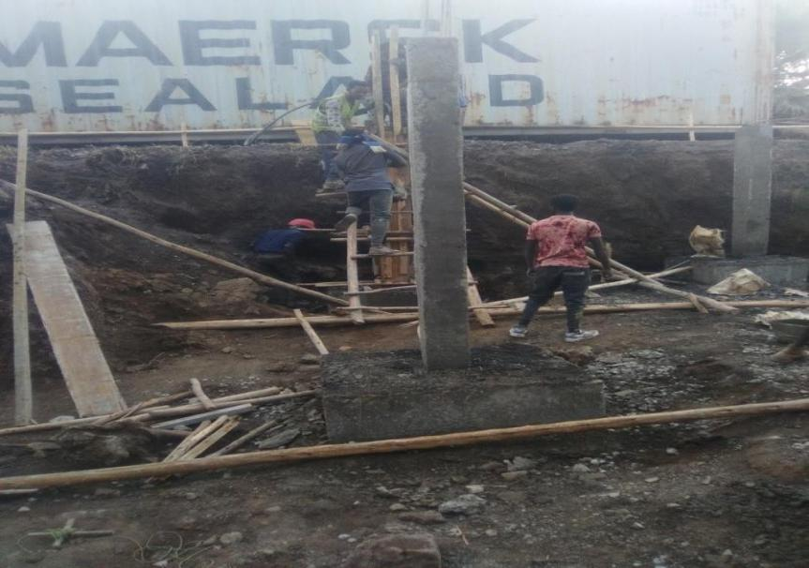

**Figure 2-6** Isolated Footing

#### Combined Foundation

A spread footing which supports two or more columns in single row is termed as combined footing. The main purpose of using combined footing is to distribute uniform pressure under the footing.

**Some reason to make it:-**

* When the spacing of two consecutive columns are close for isolated footing.
* Soil bearing capacity of the soil is lower.
* Their footings overlap with each other.

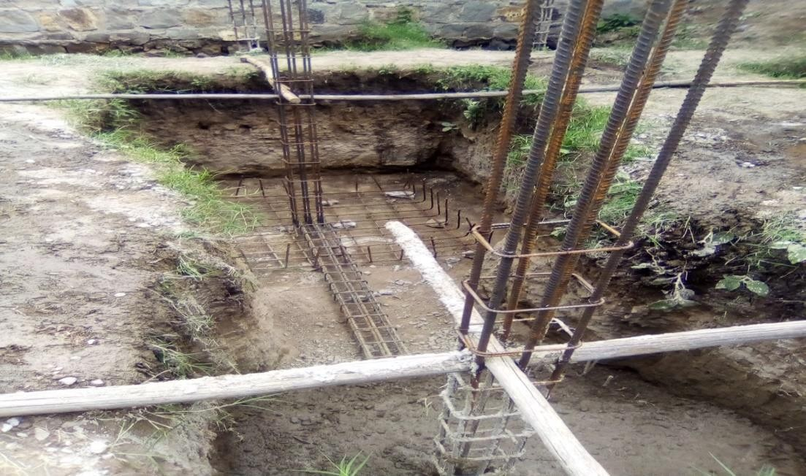

**Figure 2-7** Combined Footing

#### Compaction

Is the proses by which the soil particle are artificially rearranged and improves characteristics of soils. The use of Compaction**:**

* + Increase strength of soil
  + Decrease permeability of soil
  + Reduces settlement of foundation

#### Hardcore

Hardcore is a crushed stone layer underground floor slab or basement slab and sound approved stone specified finishing thickness and has sufficient strength to carry all the loads from the basement floor. An arrangement of hardcore is in the narrow side for easily entrance of concrete.

The use of hard core:

* + To carry loads imposed on them.
  + To prevent dampness of building.
  + 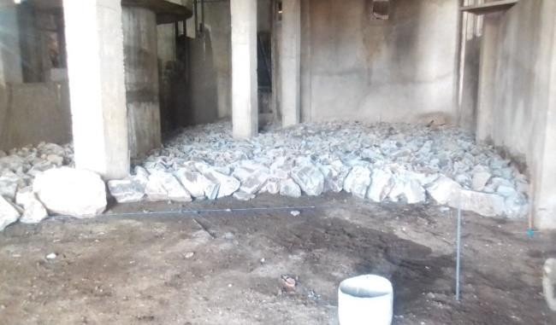To prevent growth of vegetable matter in the building.

Figure 2-8 Hardcore

#### Ground Slab

Is a type of slab that carries live and dead loads of the building and transfers in to the ground. Since the basement slab is very sensitive for temperature variation, as it has direct contact with the ground, care should be taken to safeguard the finishing materials from irregularities.

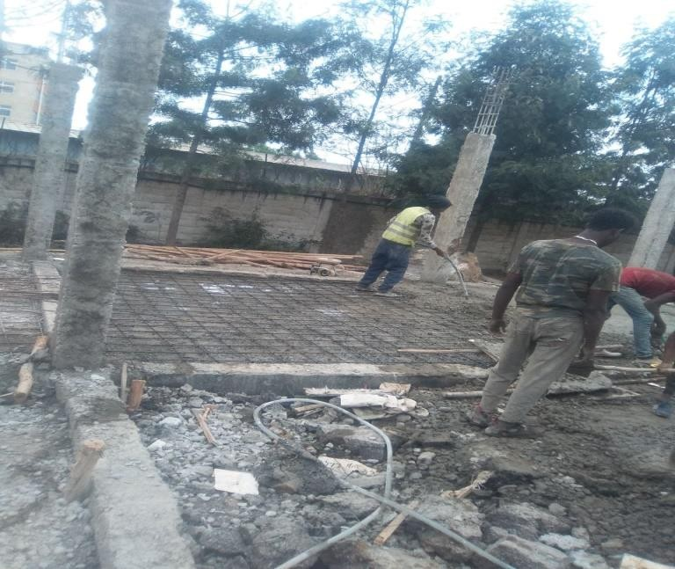

Figure 2-9 Ground slab Procedures of ground floor work:

* + 1. After placement of hard core, provide secondary rebar (mesh reinforcement) which have 8mm diameter with 15cm spacing.
    2. Prepare material and equipment‟s used to prepare concrete. (Material like cement, sand, aggregate, water ;equipment like rotary mixer, batching box.)
    3. Batching material using standard batching box (50*40*18) with 1:2:3 mix ratio.
    4. Mixing material using rotary mixer.
    5. Conveying (transporting), placing, compacting concrete and finally making smooth surface.
    6. Curing for 21 days.

Providing of secondary rebar (mesh reinforcement) used for:-

* + - * To prevent concrete shrinkage due to temperature
      * To reduces earthquake
      * To transfer load to hard core

#### Construction of Retaining Wall and Massonary Work

Retaining wall and Masonry is the building of structures from individual units laid and bound together by mortar. It is highly durable form of construction. However, Brick, Stone and concrete blocks are the most common types of masonry in use. Both are constructing under the grade beam for the purposes of:

* + - * To carry the grade beam.
      * To distinguish cracks due to settlement.
      * To help prevent soil erosion.
      * To create usable beds out of steep terrain and to provide decorative or functional landscaping features.

In our site retaining wall was constructed when the height of wall greater than one and stone masonry was constructed when the height of wall less than one. Our retaining wall height is 1.20m at the bottom begging at 80cm and at the top finished at 50cm When the stone masonry wall is constructing width started from 50cm of the base to 50 cm at the top. The mortar the mixture must be workable so that it can be placed and finished without undue labor.

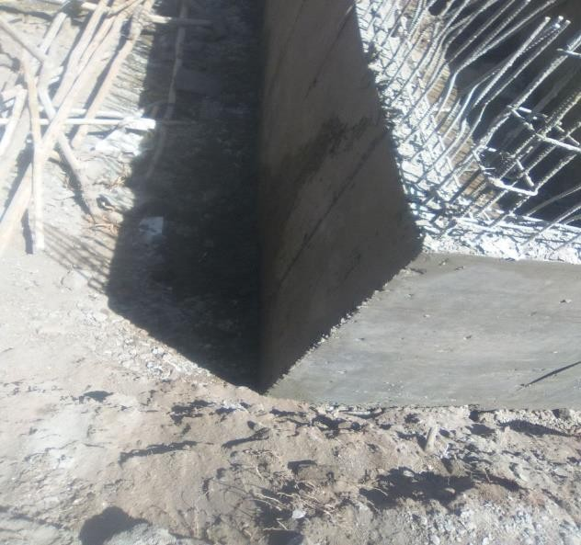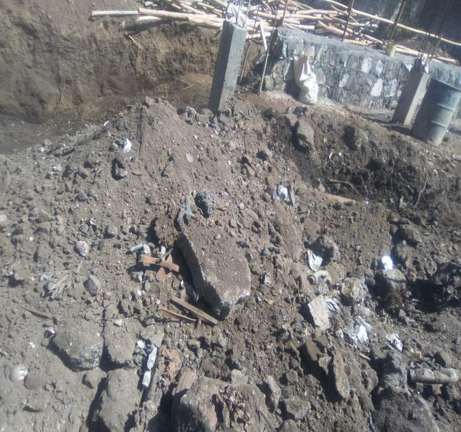

**Figure 2-10** Massonary Work

.

…

## Supper Structure Activities

Is the part of the building above the profile level or grade beam. From superstructure in our site I have seen the elevation column tasks.

1. **Columns**

Columns are reinforced structures which transmit the axial loads to the foundations. It is used to Carry and transfer loads from slabs, roofs and beams to the foundation. Columns vary in size and shape as its design. There are circular as well as rectangular columns in shape, the circular column have higher strength than rectangular and aesthetically beautiful. As we know theoretically column has longitudinal (resist lateral load and axial load with aid of concrete) and lateral reinforcement /stirrups (prevent buckling and tie the longitudinal reinforcement).

In our site, where I have been working on it, the shape and the size of all columns are the same, having 20*30 the only difference is arrangement and diameter of bar reinforcement

Procedure followed to construct a column:

* 1. Tie reinforcement bars on the starter bars.
  2. Keep tie spacer to the longitudinal reinforcement.
  3. Placement of formwork on the four sides of elevation column and brace.
  4. Fix form work by karabat at its position.
  5. Keeping form work straight vertical by fixing gindila diagonally.
  6. Use plumb bob cast concrete as per design.
  7. Remove the form work on the next day.

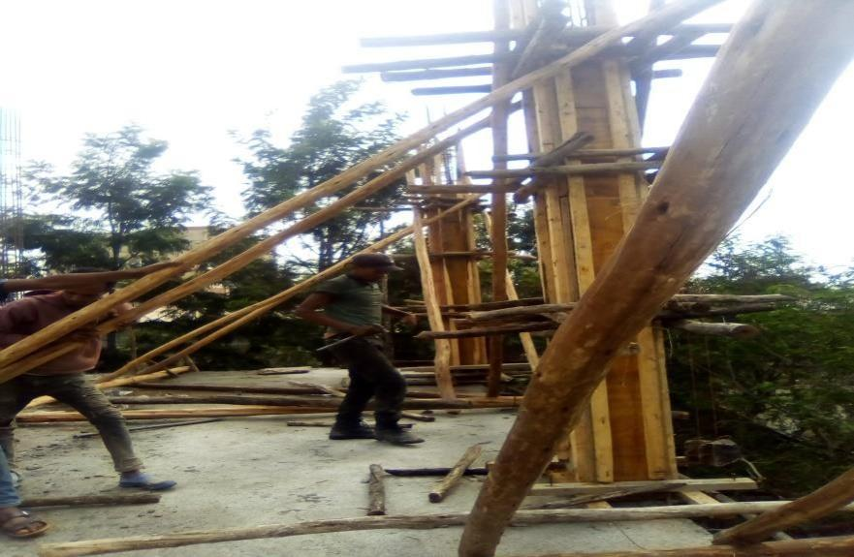

Gindila

Stanga

Karabatt

**Figure 2-11** Casted elevation column

1. **Beams**

Beams are members that resist loads by means of internal moments and shear forces. There are two categories of beams depending on their positions; these are **grade beams** and upper **floor beams**. As their name implies, the grade beams are the beams found a top of foundation of a building and near a ground level. At this project I saw grade beam. As I know theoretically and practically that beams must be reinforced the position where tensile cracking is expected to occur. This is fulfilled by reinforcing beam at the bottom and top.

* The reinforcement overlap to the bottom at the support of the beam because at the support tension is above the neutral axis
* The reinforcement overlap to the top at the mid span because at the mid span tension is below the neutral axis.

The length of overlap depends on the diameter of the reinforcement. While the diameter increase the length of overlap increase.

Procedure followed to construct a beam:

* 1. Place one side form work
  2. Reinforcement placement
  3. Tie stirrups on the given c/c (staffa) with black wire by guxet
  4. Check the c/c and the required bars existence
  5. Insert spacer b/n the bars and the form form work
  6. Keep the form work
  7. Cast the concrete

During the arrangement of reinforcement for the construction of beam we have four different types of reinforcement bars;

* **Main bars-** these bars are placed at the four corners of a beam, The gap between the main bars shall not be less than 25mm to let aggregates of concrete pass properly.
* **Positive bars** – These kinds of bars are mainly used to resist the positive moment. This moment is mostly developed at the mid span on the beams and these positive bars are placed at the mid span
* **Negative bars** – these are bars used to resist negative moment. Most of the time they are found at the support of the beams. They are placed on 1/3 of span length from the center of the column to top, where bending moment is maximum.

**Stirrups–** They are placed to provide diagonal shear resistance, most of the time we use 8 and 10 bars for stirrups, It is highly resistant to diagonal tension crack. The spacing can be wider at the mid span because the shear stress at spans is less than at supports. The use of stirrups is to hold the bar in a given spacing, to keep the position of reinforcement bar,to keep the shape and also to prevent shear failure on the structure.

#### Form Work

The formwork is a temporary construction materials used as a mould for the structure. In which concrete is placed and in which it hardness and matures. The construction of formwork involves considerable expenditure of time and material. When the concrete has reached a certain required strength, the formwork is no longer needed and is removed. The operation of removing the formwork is commonly known as **stripping.** Commonly On site, water impermeable coatings are applied to formwork. This coating prevents form adhering to concrete and makes the stripping easier. There are two types of formworks these are:

#### Timber formworks (plywood) 2. Steel formworks (panel)

**Figure 2-12** Plywood **Figure 2-13** Panel

Plywood and Panel are the most common materials used for formwork construction. Both of them have their own advantages and disadvantages.

#### The advantages of wooden formwork are:

* + - We can give it the required dimension
    - Easily available and Cheap in price

#### The disadvantages of wooden formwork are:

* + - The possibility of warping, Cracking, swelling and shrinkage
    - Has low rigidity
    - The surface of finished concrete is not smooth.

#### The advantages of steel formwork are:

* + - It provides ease of stripping,
    - Ensures an even and smooth concrete surface.
    - It possesses greater rigidity
    - It is not liable to shrinkage or distortion comparatively.

#### The disadvantages of steel formwork are:

* + - more cost

**Column Formwork**

The construction of column formwork is the most critical thing and simplest. It consists of sheeting all- round the column periphery according to the specified dimension and braced strongly. We have to check the followings before concrete are casted.

* Center to center spacing
* Vertical and horizontal alignment and The formworks dimension

#### Concrete work

The components included under this concrete works are:-

1. Cement
2. Water
3. Fine aggregate and
4. Coarse aggregate

#### Cement

It is the setting agent of concrete and the bulk of cement used in my site is PPC. Which ever type of cement is being used it must properly store on site to keep it in good condition. The cement shall be stored in a dry and well ventilated store with a wooden floor which is raised minimum 20cm above the ground level.

Field Tests for Cement

* Color Test of Cement- The typical color of the cement should be grey with a light greenish side. This color should be uniform.
* Presence of Lumps- Due to the moisture from the atmosphere, cement develops lumps. But it‟s not good to use that for construction. Any bag which is delivered to the site with lumps should be rejected.
* Date of Packing**-** Strength of cement reduces with time, so it is important to check the manufacturing date of the cement. The general fact is that the cement should be used before 90 days from the date of manufacturing.

#### Water

It is used in concrete mixes has two functions; to react chemically with the cement which will finally set and hardened, and to lubricate all other materials and make the concrete workable. Generally, water should be cleaned and free from impurities which are likely to affect the quality or strength of the resultant concrete.

#### Fine Aggregates

Shall be clean river or pit sand of approved quality. In my site before any sand is delivered to the site the quality shall be checked against the following field test.

* **Test 1:-** take a glass of water and add some quantity of sand in it then shake vigorously and allow it to settle. If clay is present in sand it will form a distinct layer at the top of sand.
* **Test 2:-** take sand and rub it against the fingers if fingers are stained indicate that sand contains earthy matter.

#### Coarse Aggregate

Those materials are mixed with cement to form concrete. Generally, an aggregate consists of 65-75% of the volume of concrete. The aggregates should be well graded in order to minimize cement paste and improving workability. In my site we used 30mm aggregate sizes. Concrete solidifies and hardens after mixing with water and placement due to a chemical process known as hydration. They can move mass of concrete by barilla and by senkelo up to required position.

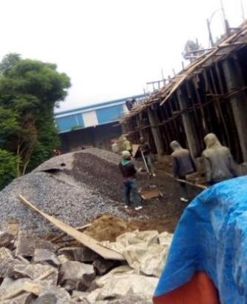 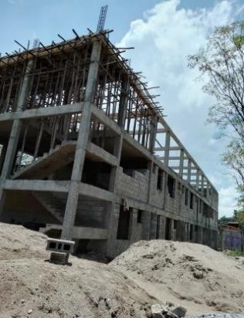 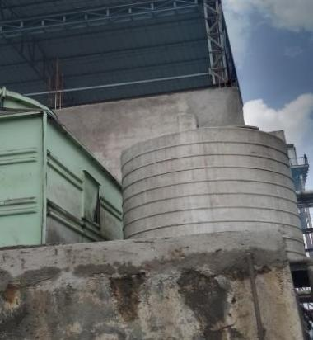 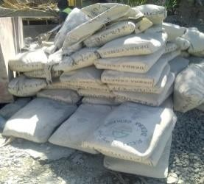

**Figure 2-14** Aggregate **Figure 2-15** Sand **Figure 2-16** Water tanker **Figure 2-17** Cement

#### Batching of Concrete

A batch is one mixing of concrete and can be carried out by measuring the quantities of materials required by volume or weight. In my site we use volume batching.

**Volume Batching: -** are often quoted by ratio such as 1:2:3 (cement, fine aggregate or sand, and coarse aggregate) respectively. To ensure accurate amounts of materials are used for each batch gauge box should be employed its size being based on convenient handling. Ideally a batch of concrete should be equated to using 50kg of cement per batch. During 1:2:3 mixing ratio the size of box batches used in our site for C-25 50cm*40cm*18cm box size.

50cm*40cm*18cm Measurement

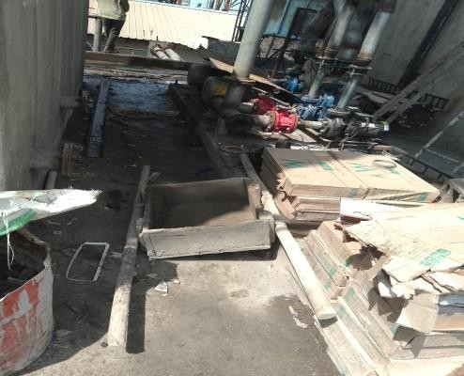

**Figure 2-18** Batching material

#### Concrete Mixing

This process should ensure uniform colour, consistency, and homogeneity of the concrete. Segregation should not take place during process of mixing.

Generally they are two types of concrete mixing:- machine mixing and hand mixing. In my site we use only machine mixing.

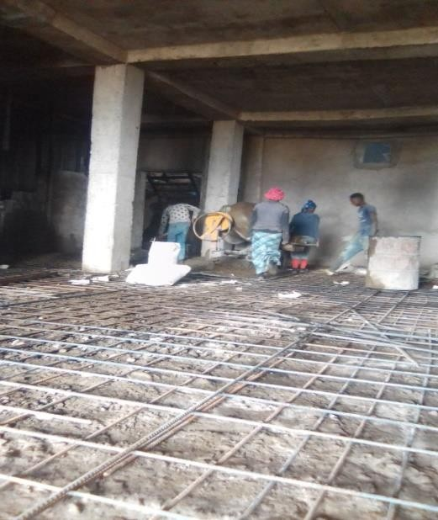 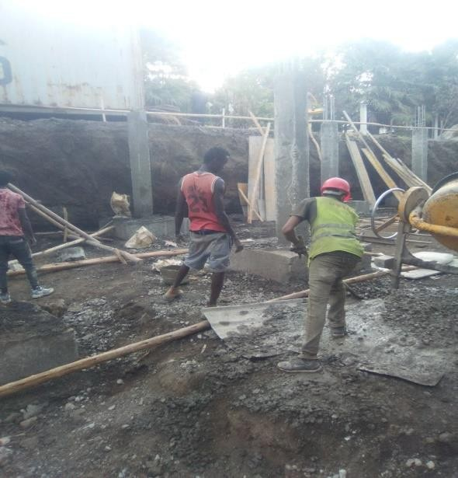

**Figure 2-19** Concrete mixing **Figure 2-20** Fresh concrete

The materials should be placed in to the mixer in following order:

* half the volume of the water
* coarse aggregate
* Fine aggregate that the water cement ratio shall always kept constant.
* cement
* the rest half volume of the water Requirements to be mixing the concrete by mixer
* The mixer shall be thoroughly clean from hardened concrete and other kind of dirt before use.
* The specified mixing time should be carefully adhered to.
* The mixer not overloaded. Check the capacity of mixer and don‟t allow the contractor to mix bigger batches than specified.

#### Concrete Mix Design

The properties of a freshly mixed as well as the resulting hardened concrete are closely associated with the characteristics and relative proportions of the component materials. It is therefore obvious that by determining the relative quantities of given types of materials prior to mixing, one can produce a concrete of desired properties. This process is known as Mix Design or Mix Proportions. From standards, it is common on site that the amount of ingredients used to make concrete of different compression strength is known. For example; to make a one cubic meter of C-25 concrete, 1:2:3 proportion of cement, sand and aggregate is used.

**Table 2-4** Mix proportion

|  |  |  |
| --- | --- | --- |
| Size of boxes | strength of concrete | Amount of cement |
| 50*40*18 | C-25 | 350kg/m3 |

To attain the specified compression strength of concrete, the void spaces in the concrete should be removed, to achieve this compaction or vibration is necessary. But we have to take here is that a prolonged vibration will lead to us segregation.

#### Generally, before any approval in the concrete work, the following should be checked:

* The box size used
* Cement is fresh not older than three months and is delivered to the site in the manufactures sealed bags
* Cement more than three months old after production is tested to satisfy the specified requirements
* Water used for mixing concrete is clean and free from oil, acids, alkalis, and organic materials

#### Curing of Concrete

Moisture is necessary for the proper hardening of concrete because the chemical reaction that results in the setting and hardening of the paste takes place only in the presence of water It is important therefore that fresh concrete be kept moist for several days after placing. This process known as **curing** should begin soon after the concrete is set and continue preferable for a number of days.

#### From the above, the purpose of curing can be summarized as follows

* Curing is to prevent formation of surface cracks due to rapid loss of water while the concrete is fresh and weak and minimize segregations.
* To assure attainment of strength by providing enough moisture for the hydration process.

#### Types of concrete

There are two I observed in the site.

* + - 1. Reinforced Concrete and
      2. Lean Concrete

#### Reinforced Concrete

Reinforced concrete is a composite material made of concrete and steel and is advantageous than other types of concrete this is due to its strength both in tension and compression. Concrete is good in compression but weak in tensile strength. To overcome this problem steel is incorporated in it and become reinforced concrete. All the sub structure and super structure are reinforced concrete**.**

#### Advantageous of Reinforced Concrete:-

* + It is monolithic. This gives it more rigidity
  + It is durable. It does not deteriorate with time
  + While it is plastic. It can be moldable in to any desired shape
  + Its maintenance cost is practically less.

#### Reinforcement bars (steel)

The steel used in reinforced concrete consists of deformed bars, mostly of the deformed types, with projection on their surface. The projected surface will help to develop a greater bond between the concrete and steel. On the site as I have seen that reinforcement bars of different size in diameter are used as per the structural design. For instance:

* + For stirrups and shear 8mm bars
  + For pad 14mm and 16mm bars
  + For grade beam 14mm bars.
  + For footing columns and column 16mm.

Engineer Molla who is daily interested to create awareness about everything what the workers do on the site, shown me that how the reinforcement bars are tied together, location of negative bars, overlapping of bars & their arrangements by combining theoretical concepts with that of the practical ones on the site.

The bending of reinforcement bars can be carried out on site manually based on the specified structural drawing by pulling them round mandrel.

#### Generally, during supervision of reinforcement bar, the following should be checked:

* Steel reinforcement is stored in clean condition. It should be free from loose rust.
* The dimensions length and shape of the reinforcement bar is according to the drawing and specification.
* All bars with cracks or splits at the bend are not used for construction.
* All the reinforcement bar are clean and free from close rust, grease, oil and other kind of dirty.
* The reinforcement bars are placed in position according to the drawing and firmly bound together with mild steel wire (black wire).
* Before any casting concrete starts, the precast concrete blocks (spacers) are prepared and all reinforcement bars are placed on it.
* The thickness of concrete cover is according to the requirement of the drawing and specification.
* The reinforcement in structure is not welded unless permitted by the designer.
* All reinforcement quality and work should be according to the standard technical specification.

#### Lean Concrete.

is a mixture where the amount of cement used is less than the amount of liquid present in the strata. Lean concrete is that concrete which is high aggregates to cement ratio. Lean concrete is concrete of 5mm thick with class C-5 with minimum cement content of 150kg/m3 of concrete. Its ratio is 1:4:6.

I observed in our site lean concrete used:

* + On footing below reinforced footing
  + before starting masonry work and partion grade beam

#### Advantage of Lean Concrete

* + To provide the uniform surface to the foundation concrete
  + To prevent the direct contact of foundation concrete from the soil
  + To protect the main foundation from soil below, as moisture or ather chemicals in soil like sulphates may attack concrete and weaken it.

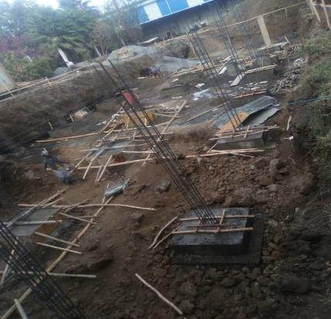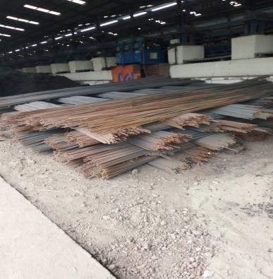

**Figure 2-21** Reinforcement concrete **Figure 2-22** Reinforcement Bar

#### Spacer

Spacers are materials (either reinforcement bars or wire imbedded concrete) which provide space for the concrete to cover the reinforcement bars in columns, beams…etc

The cover to reinforcement is required for the following reasons:

* + - To protect the steel against corrosion.
    - To provide sufficient bond or adhesion between steel and concrete.
    - To ensure sufficient protection of the steel in a fire.

In all blocks found in our site used the following spacer size Table 2-5 Spacer size

|  |  |  |
| --- | --- | --- |
| No | Structural part | Size of spacer |
| 1 | Columns | 50mm |
| 2 | Beams | 50mm |

#### Vibrator

Vibrator is used to compact concrete mix and to avoid air voids in the concrete mix. The presence of air voids in the concrete reduces the strength of concrete and when dry it will create cracks. In this regard, vibrators are the essential equipment for every concrete casting.

#### Stripping time

Stripping is the process of removing formwork. The time required for this phase is different for different structure. The time required for most common structure is listed in the following table.

**Table 2-6** Stripping time of formwork

|  |  |
| --- | --- |
| SECTION | PERIOD OF REMOVAL |
| For vertical formwork to column | 16 hours |
| Grade beam and pad formwork | 16 hours |

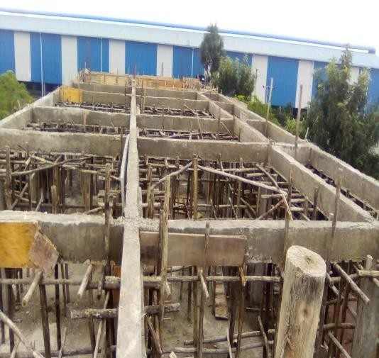

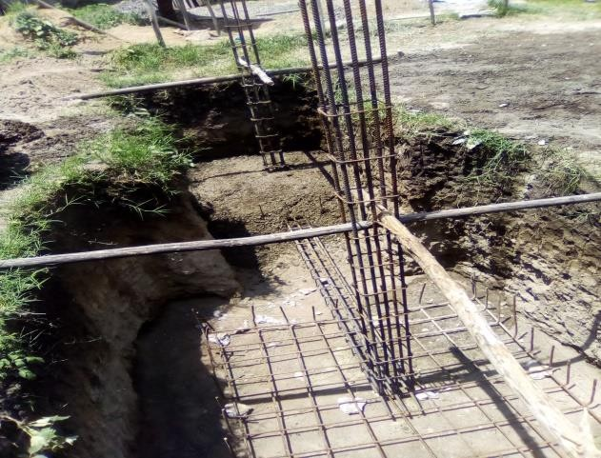

Spacer

**Figure 2-23** Spacer for footing **Figure 2-24** Stripping Top tei beam

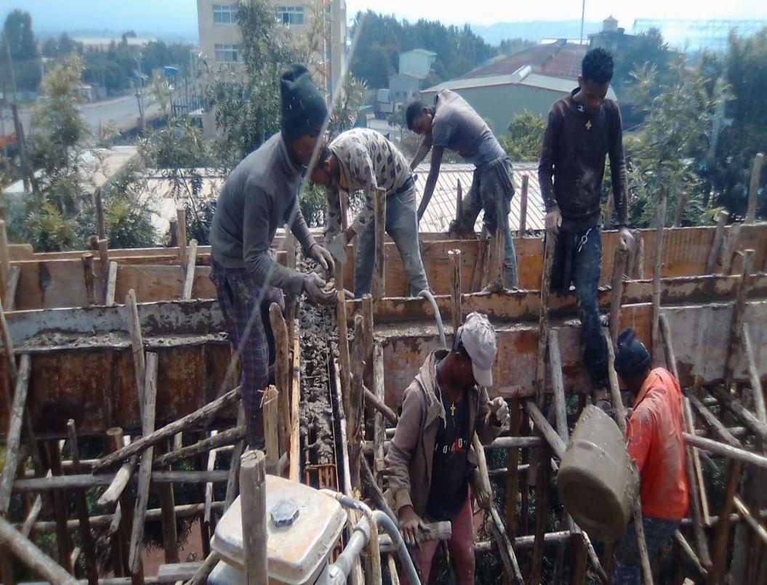

Vibrator machine

Top tei beam

Concrete transportation

**Figure 2-25** Vibration Process

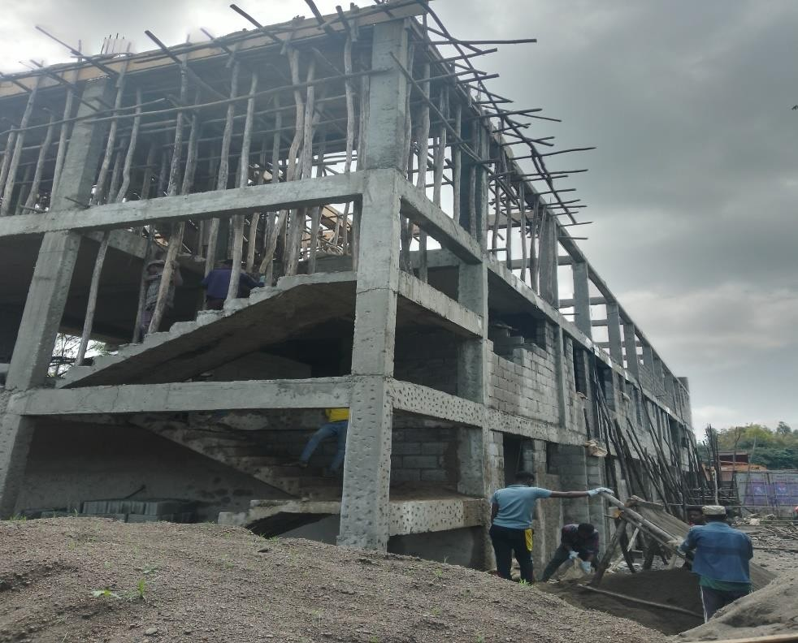

**Figure 2-26** Current figure of Building

#### The Procedures I have Been Using While Performing My Work Tasks

The procedures I have been using while performing my work tasks can be discussed both in the site work and in the office work. In the site work, first I tried to know and internalize each and every activity which is held on the site. But most of the time, since the technical terms used in the field (site) are difficult to understand for me, I tried to listen on the site and if the workers on the site (especially the daily

professionals) do not have free time and they were very busy then I will ask workers in the office and the Forman on the site. In the office work, I was performed my tasks with less difficulty compared to the performance in the site. Mostly, we (students) are expected to have better theoretical knowledge than the practical skills. So, this was the reason for less difficulty I face here. Initially, when I was given work tasks for me and the site engineer explains the tasks briefly and guides me how to do it. After I receive the tasks, I classify it among myself and work separately. But if I need support, for instance, it is open to ask the site engineer and foreman.

#### How Good I have Been in Performing My Work Task

In my first two or three weeks of my internship, I was been dependent on my site engineer who is responsible to train me but later I gain more experience of I try to do things on my own way. But it is important that you make good impression of work. If I make a good impression on my work, he is more likely to give me more responsibility which can lead to promotion and raises.

Sometimes I make mistake at a work which everyone is inevitable does at some point. Some of the mistake I face while I was taking a measurement or checking an alignment was corrected by the site engineer. Since I am working with site engineer. But the most important thing is I do not ignore my errors or I do not want to place the blame on others rather than myself. Because it‟s me who take responsibility and I have to come up with solution to fix my mistake. My boss may not be too happy about it, but he will at least be impressed with my response.

I mostly want to concentrate on things that are related to my work activity‟s and try to avoid topics which may not help me to make a good impression at work. But it will keep me from making a bad one. Subject that do not make for good work place conversion including, political, religion, health problems and other personal issues should be avoided, this factors are responsible to make the work efficiency and work process more less. Sometimes this thing my lead to conflict resulting in physical damage as well as properties and psychological

Managing my time effectively is crucial thing to my work. My ability to complete my work in a timely manner will help me to be more lovable and more believable to my jobs. I should demonstrate that I know how to manage my time effectively by handling project when or even before my deadline. But there are some things that greatly influence how to manage my time as well as the working progress. Some of these factors are scarcity of material, nature of the work, lack of skilled man power.

Finally in construction work a team work is more crucial. Since it needs a different number of people who are skilled with different disciplines. This team work is crucial for my effectiveness as working as supervisors or managing the works. Even if I am not in management or leadership role yet, better understanding a team work can make more effective employee. The other crucial element of team

work success is that all the team effort are directed toward the same clear goals, the team goals relies heavily on a good communication in the team and the harmony In member relationship.

#### Challenge I have Been Facing While I Perform My Work Task

It is known that one of the main interesting and needed point of the internship program is to see the different challenges that any professional may faced during his work. When I say I did this and that, it does not mean that all things are smooth during my work, as any professional encountered different challenges. The following are some of them:

* + - * Shortage of information in the working drawing.
      * At the beginning of the apparent lack of experience, gaining responsibility and has no any task given to me it will decrease my moral of work there.
      * Shortage of office material like computer.
      * Lack of construction safety wears i.e. safety shoes, helmet, and gloves….etc.
      * Temperature.
      * Site language: - when I joined in to the project the name of the construction material made confusion. For example the language of the carpenters that are used to name the material such as, Sponda, Tumby, Modini, Staffa etc.

#### Measure to Overcome Challenges

The measures I took to overcome these challenges are:

* Asking the site engineer
* Work efficiently to any task given by my site engineer
* I tried to use my own materials

To solves the challenges regarding to **site language** I decided to create a good relationship with the employees and daily workers of the project. All things are simple to know on process after a time, to know the work task of each employees I decided to arrange a program that meets with the employee two days per one week for each then the problem is solved and they are volunteer (responsible) to accept my program.

## CHAPTER THREE

**OVERALL BENEFITS OF INTERNSHIP**

My internship time has been the most educating and challengeable time I believe that every intern had their own expectation about working in actual construction site. The benefit of internship can be expressed from different perspectives. This are in improving practical skills, theoretical skills, interpersonal communicating skills, team playing skills, leadership skills and work ethics. Really this internship program has many advantages some of these are as follows:-

#### In Terms of Practical Skill

The aim of the internship is to address more practical knowledge for student. So, I found a practical knowledge at the site as much possible within the three month. The knowledge we have learn in the class is helpful to get those practical or real work in the site and totally different from the actual knowledge gained from the class. Thus I found some knowledge in the site which helps me to work with the site environment or site peoples. During my three month of internship, I have learned a lot about the process of construction. Basically I have more benefited on the following practical experiences.

* Improved my ability of understanding and reading working drawing.
* Concrete casting.
* Ratio of mixing proportion.
* The need of vibrating while casting.
* Preparing takeoff sheet.
* Supervision and checking of reinforcement and formwork.
* The communication language used at the site.
* I know how to place the reinforcement bars in the structure.
* How to select construction materials. For example: to select sand, aggregate and cement.
* How to identify the diameter of the bar visually.

Generally, this internship program develops my practical skill and it helps me to understand each of every construction activity easily than theoretical way. Because I directly observed my theoretical knowledge from the sites now in this time of my stay I have not got the chance to see the finishing parts like ceramic, and the roof truss work but I have got the practical knowledge from structural parts like foundation, grade beam, column and ground slab.

#### In Terms of Upgrading Theoretical Knowledge

In most educational program in previous 7thsemisters of study, have taken various courses in the class. This internship program has good opportunity for civil engineering students to advance and more improve the theoretical knowledge that have gained during their study from Mattu University. Therefore, during this internship the students have been able to understood and upgraded their theoretical knowledge in visible practice from the site and of construction. Some of them are:-

* In what position I must overlap reinforcement bars for the columns and beams.
* I able to differentiate between take off sheet and re-bar schedule.
* Concrete works including ways of material proportioning, mixing, transporting, casting and curing
* Reinforcement works including bar cutting, bending and placement preparation of mesh for ground slab.

#### In Terms of Improving Interpersonal Communication Skills

On a daily basis I work with people who have different opinions, values, beliefs and needs than me to be seen in practice and this internship program helped me to increase my communication skill with all of these peoples and also helps me to increase my ability to exchange ideas with those people. I also develop this two core things for communication the other thing I also learned from this internship is

* + How to communicate with different peoples with different profession
  + How to communicate with my supervisor
  + How to communicate with my Forman
  + How to communicate with the labors

#### In Terms of Improving Team Playing Skill

It is the way how to cooperate with different people. Team playing allows us to make friends and enjoy a better social experience when studding and working. In site it is very important to play as a team. If there are disagreements between any parties which are participated in the project it is very difficult to go ahead with the construction works. Knowing this I have developed team work playing skill both by practicing and observing during my internship. In the first two weeks I worked hard to participate on team works. This time was completely wonder full in developing my team playing skills, and much more all the tasks I have been handling were team works.

Skills that I developed for being good team player:

* I learned how team works create collaboration among team members.
* Develop friendship among the teams and others.
* Develop knowledge through many sharing different ideas openly.
* Team members must know how to examine team and individual errors without making personal attacks.
* The team member should express their opinion without any fear.
* The must be good information gather about the work.
* To listen to question and concerns other suggested ideas.
* To learn from other sharing ideas and motivating.
* I learned that how team works create trust between team members.

#### In Terms of Improving Leadership Skill

Since engineering projects are typically done by teams, an engineer needs a good communication skills and leadership qualities. During my internship time, I tried to be able identify leadership skills, styles and ability.

#### That is:-

* + How to use human resource to increase the level of productivity and the gains in cost reduction in the future works.
  + Helps me how to manage the project and general work flow of the project like division of labor, work flow of the project, responsibility, authority and unity of command from top to bottom of the company.

Generally I have gained the knowledge to be a good leader of project or I have learnt from things how I can lead if I seat in once position. Like Forman or project manager.

#### In Terms of Understanding Work Ethics

In every profession, there are ethics to be followed. These rules help workers maintain appropriate professional discipline. Without these ethics, it would be difficult to conduct ones work effectively. There is labor discipline that each worker should observe and respect. These could relate to norms, mode of carrying out a work, protection of the property and means of working and managing activities. Failure to observe such ethical rules would result in penalty which ranges from suspension to dismissal. Thus workers are expected to observe professional rules so as to be more productive and to establish good support with other workers. Work ethics have the following components

* Productivity
* Attitude
* Professional relation ship
* Self-management and punctuality
* Honesty
* Respect construction law
* Respecting to take unfair advantage

Among the above work ethics I learned many things but the most important thing I learned is **punctuality** it is a very important weapon for work it is not only coming to the work place on time but also being available during working hours if a scarification of time is needed from our personal time, meeting deadlines for the work to go smoothly, Handling property in better ways.

Work ethics such as honesty (not lying, chatting and stealing), doing a job well, valuing what one does having a sense of purpose and filling /being a pert a greater vision or plan is vital. Philosophically if one does not have proper work ethic, a person‟s concise may be bothered people for the most part have good work ethics/; we should not only want to do, but design to do the proper thing in a given situation. Work ethics are intrinsic. The company that I have internship program have put with a document the right and regulation of workers

In every my activities I follow all the regulation of the company because of these I improve my work ethics skills on my work tasks, such as

* Friend well relation with the whole workers.
* Come in the morning on time before the work started.
* Follow the rule on the production and on the usage of construction material.
* Never do bad thing that put negative sign on the project.
* Do every works all my assistance gives for done.
* Cooperation: - being interactive and cooperate with the others.
* Office discipline: - in work place you don‟t have to disturb the working condition.
* Punctuality: - means keeping the companies work beginning time to compete the given task on the given period.
* Accountability: - accountability is a key requirement of good engineers.
* Open mindedness: - I have to be open minded since it makes the work to be done understandably.
* Professional ethics: - refers to the standards or a set of moral principles for regulating behaviors of a certain defined profession.

#### In terms of updated software

There is much software available which are used in civil engineering. Due to the technological revolution, the numbers of software serving needs are increasing. So there are much software used in the architecture, construction, engineering, manufacturing and design. Some example of software;

* + Auto CAD
  + ETABS
  + Sap

## CHAPTER FOUR RECOMMENDATION AND CONCLUSION

### Conclusion

The internship is a bridge between the theoretical knowledge and the practical or reality work at the field of construction engineering. We all who take the internship class go to companies that already working either as consultant or contractor. The responsibility of hosting companies is to teach student and shape them in the three month as real site workers. My hosting companies in a consultant team and they help me and my pear friends who took the internship session in company in acquiring different knowledge in different position. They collaborate with the contractor to teach us in the section both in civil work and consulting office work.

This program played an important role to break the conventional thought that field work can be only implemented by student who hold a degree or people who have an experience in building construction. We were able to acquire a high level of confidence to deal with problem that arise in building construction

Since I took my intern ship session in the contractor side of SIMLESS CONSTRUCTION PLC. I get an opportunity to work in the different part of construction work which helps me to gain more knowledge by watching what they work in their own office and what is their responsibilities to the client and also each other.

Working with contractor team get me more knowledge in case that the consultation work include the duty of site engineer and in consultant office there are different office that are more important for me to upgrade my knowledge in different aspect of work. The consultant team by its nature include designer team including structural engineer, architect, supervisor and quantity worker and the finical office. This help me to get more knowledge.

They help me to understand what‟s going to be when I work in consultant office. The contractor also avail practical knowledge to improve our practical knowledge status in field. And also the site engineer make us more familiar with site workers starting from communication skill, handling of different site work equipment utilization manpower control to finishing the work within the time scheduled by the client.

This internship program that will create practice oriented students that may have capacity to solve practical problems and I enjoyed my internship time more than I expected. The internship is an important made me to appreciate and know closely my profession and construction industry as a whole.

In the internship period I had the opportunity to improve both my practical skill and theoretical knowledge with the help of the workers in the company. During internship time in the company I could learn how to communicate with workers in turn I could improve my interpersonal communication skills. I was participating on both office and field works which I was able to acquire a high level of skills of building construction and also I was participating in building construction that I was doing takeoff Moreover, I had been able to learn how to construct form work, foundation, grade beam, ground slab and column of building construction with each step. Besides, I was able to understand work ethics related issues such as punctuality, reliability, honesty etc… on top of these I learned how to come up with a solution when challenges are facing during work time and also improved my team playing and leader ship skills I assure that the skills I gained in the internship will actually help me to be efficient when I get in to work after graduation because I was already familiar with the skills which are essential working environment.

Generally I got satisfactory knowledge and more benefited at intern. This internship program is real, necessary and important for engineering students. Practical program used to develop theoretical principles. We have seen what we are going to do and well informed about construction sites. In addition we develop good communication and this is central thing in dealing with activities in the site. and this is central thing in dealing with activities in the site.

### Recommendation

#### Recommendation for the company

I strongly feel about the goals of the practical attachment. It prepares the students for the real working environment. The program is also phenomenal in producing fit and competent engineers. This negligence affects the motivation and work habit of the students. Most of site worker, particularly site engineers and daily laborers do not have safety cloths like safety shoes, helmets and etc. to protect them from sudden injuries. **Therefore I recommend the company**:-

* + - * To arrange safety tools at least for site permanent workers.
      * And other problems Unprepared use of materials and miss lapping of column and beam should be updated.
      * Office for intern student should be arranged.
      * Should use modern machineries and equipment‟s.
      * Employ high professional skilled man power.
      * The company should place reinforcement bars in convenient area for protection from corrosion.

#### Recommendation for the University

* Department should arrange more contact time between the university advisors and the intern student.
* Another matter that needs change is the teaching system in my opinion which only focuses on the theoretical aspects of the subject. The attachment program helps in incorporating the practical knowledge to the educational process and it is a good start but I don‟t think only three months is enough to supply students with sufficient practical knowledge. Practices have to be all year long process and have to go hand in hand with the theoretical learning. It will help students to easily visualize what is being told in class.
* Orientation about the internship program should be given.
* The university gives for internship time money can be pay on time.

## REFERENCE

1. Minister of work and urban development proclamation “ Ethiopia building code of standard 2” Addis Ababa, Ethiopia, 2013

2.(Edward Allen and Joseph, (2003), Fundamental of building construction material and methods, wiley publishers; 4th edition.

1. Abebe dinku, Building construction, AAU Printing Press.

(Braja M. Das_ 6th Edition of PRINCIPLES OF FOUNDATION ENGINEERING)

1. [www.wekipedia.com](http://www.wekipedia.com/)

## APPENDIX

**Barella** Tools used to hold like cement**,** stone and so on.

**Berga** One Piece Of Reinforcement Bar Which The Length Of 12 Meter.

**Carpenter** Is a craft responsible for making wood structures for supporting different .

. structural componensts

**Cristie** A vertical support used to hold fondo.

**Daily laborers** Daily laborers are unskilled man workers who work as assigned on

. special activity.

**Ferrayo** A person who bend a bar

**Gindila** Is a wood located horizontally on the desired surface during form work the

. purpose of fixing rigidly.

**Guxet** Used to cut black wires

**Kerabat** Is a wood with the form work width and length of column tied on the middle

. and end of the column side.

**Kiracheri** Is a wood tied on the surface of the concrete pad in each side of the column

. surface which carries the column form work.

**Masons** Is a person who is skilled at building things with stone.

**Qisit** Used to support side form work/sponda.

**Senkelo** Tools that used to transfer concrete

**Sponda** Side formwork

**Staffa** The so called stirrups and its name give site workers.

**Tumby** Called plumb-bob used usually in the site for the purpose of cheekiness the

. verticality of the particular structural elements.